# PROPERTY BUYING &RENTALS

**STEP – 1:**

Create a new application from scratch.

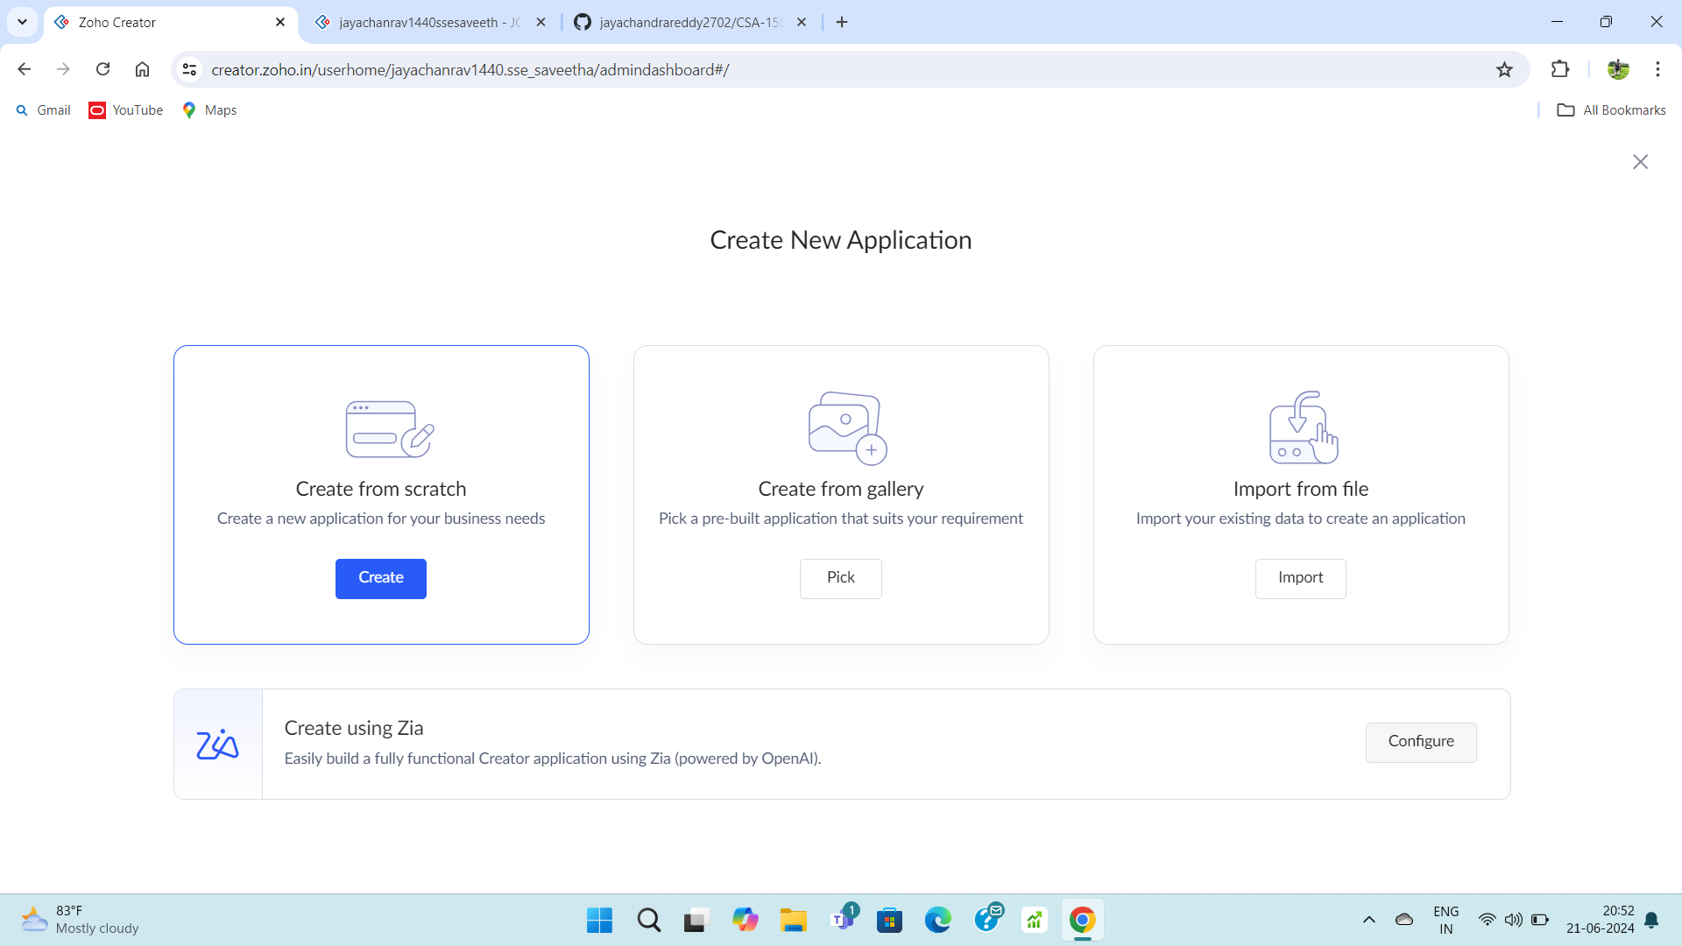

**STEP – 2:**

Create a new form.

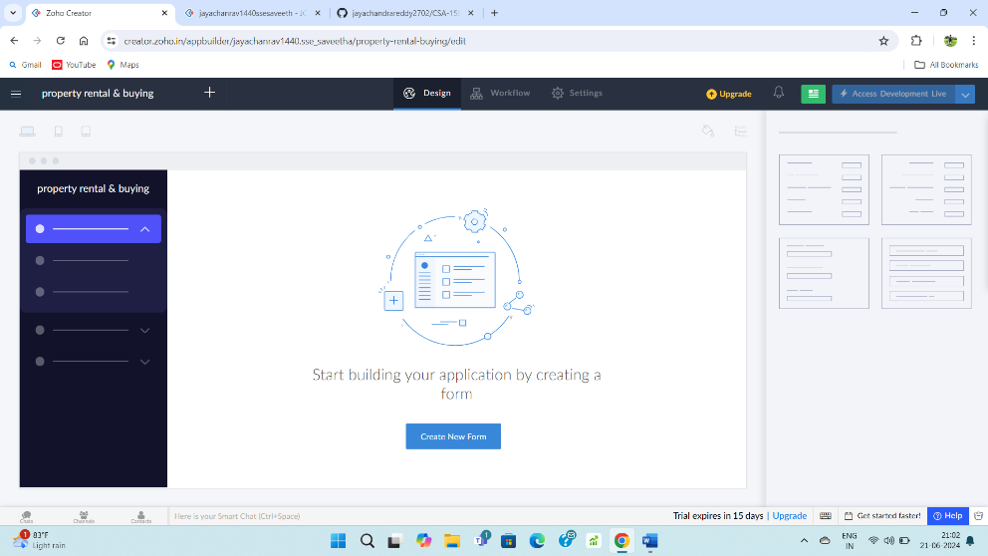

**STEP – 3:**

Create a login form and give required fields.

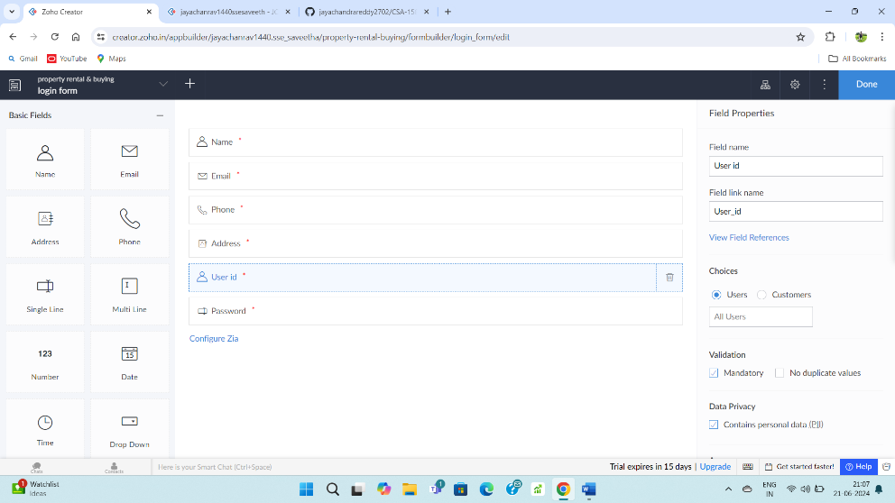

**STEP – 4:**

Fill upon the created form.

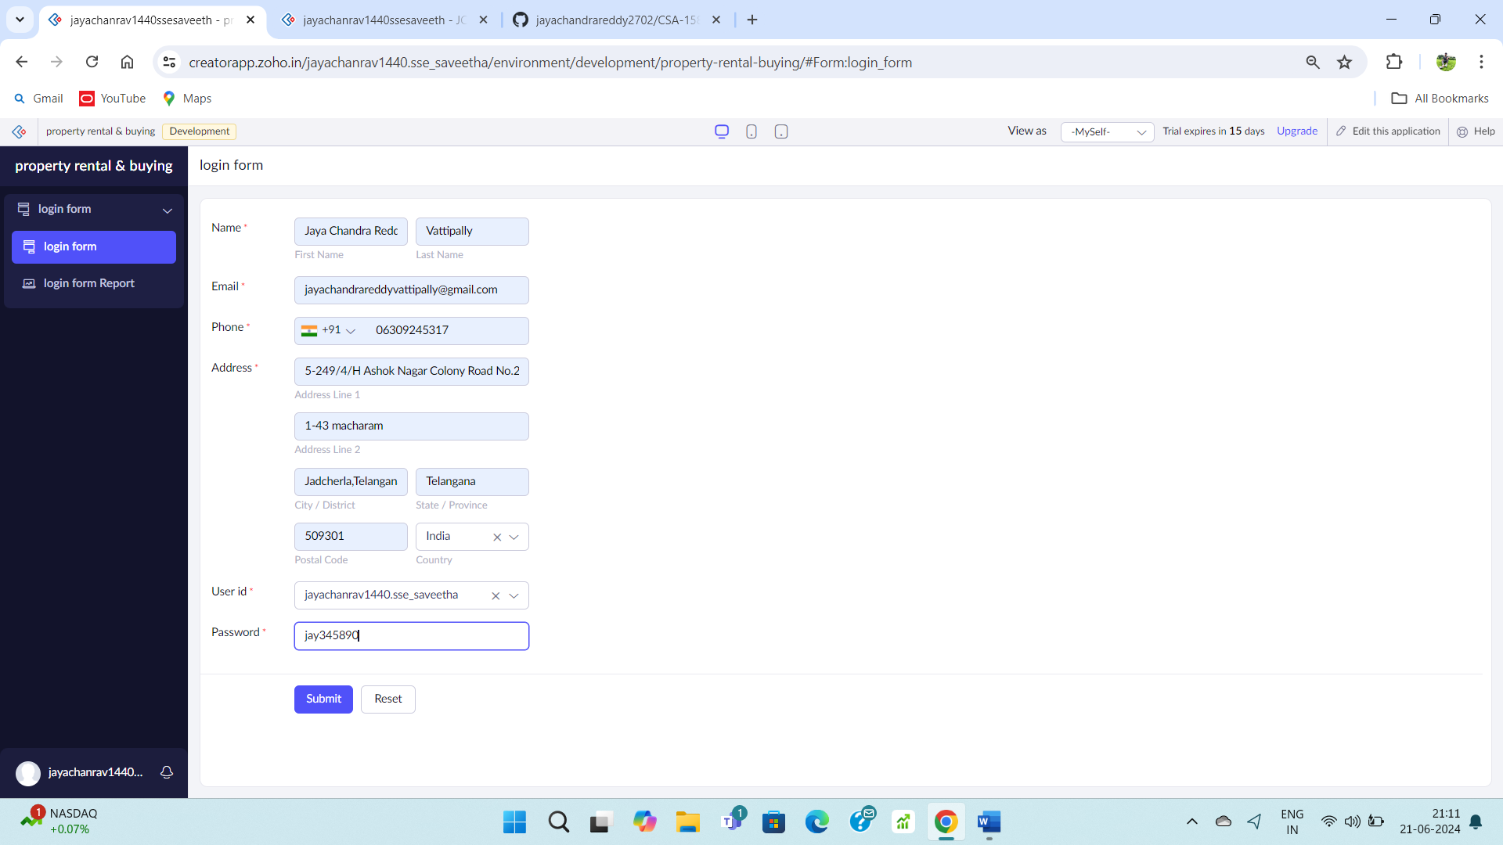

**STEP – 5:**

Go to login report form.

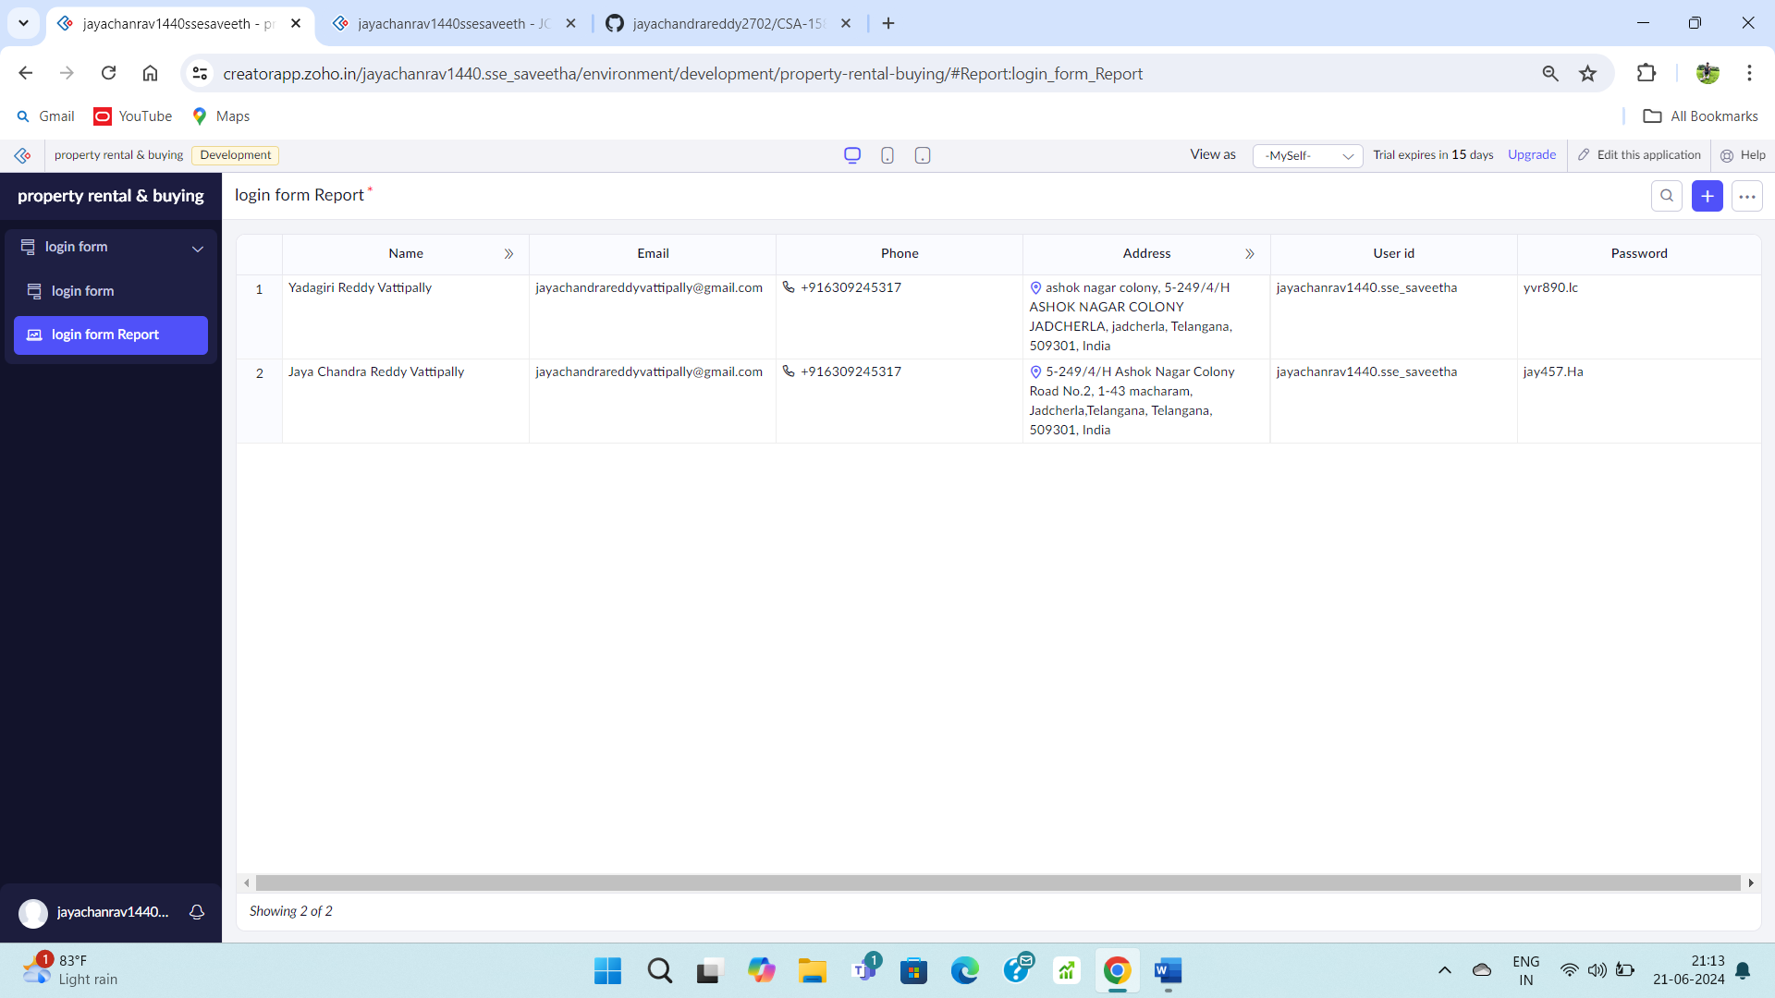

**STEP – 6:**

Create a property buying & rental form.

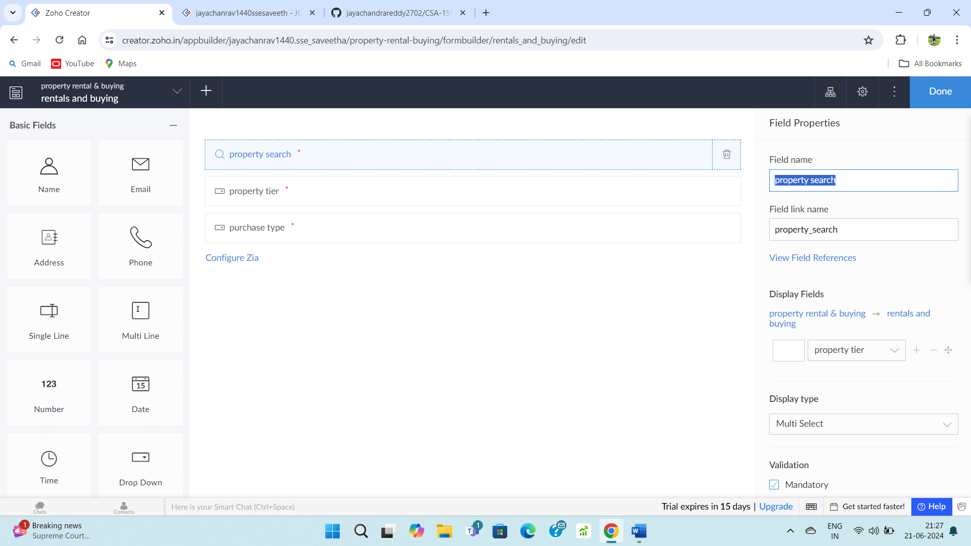

**STEP – 7:**

Fill upon the created form.

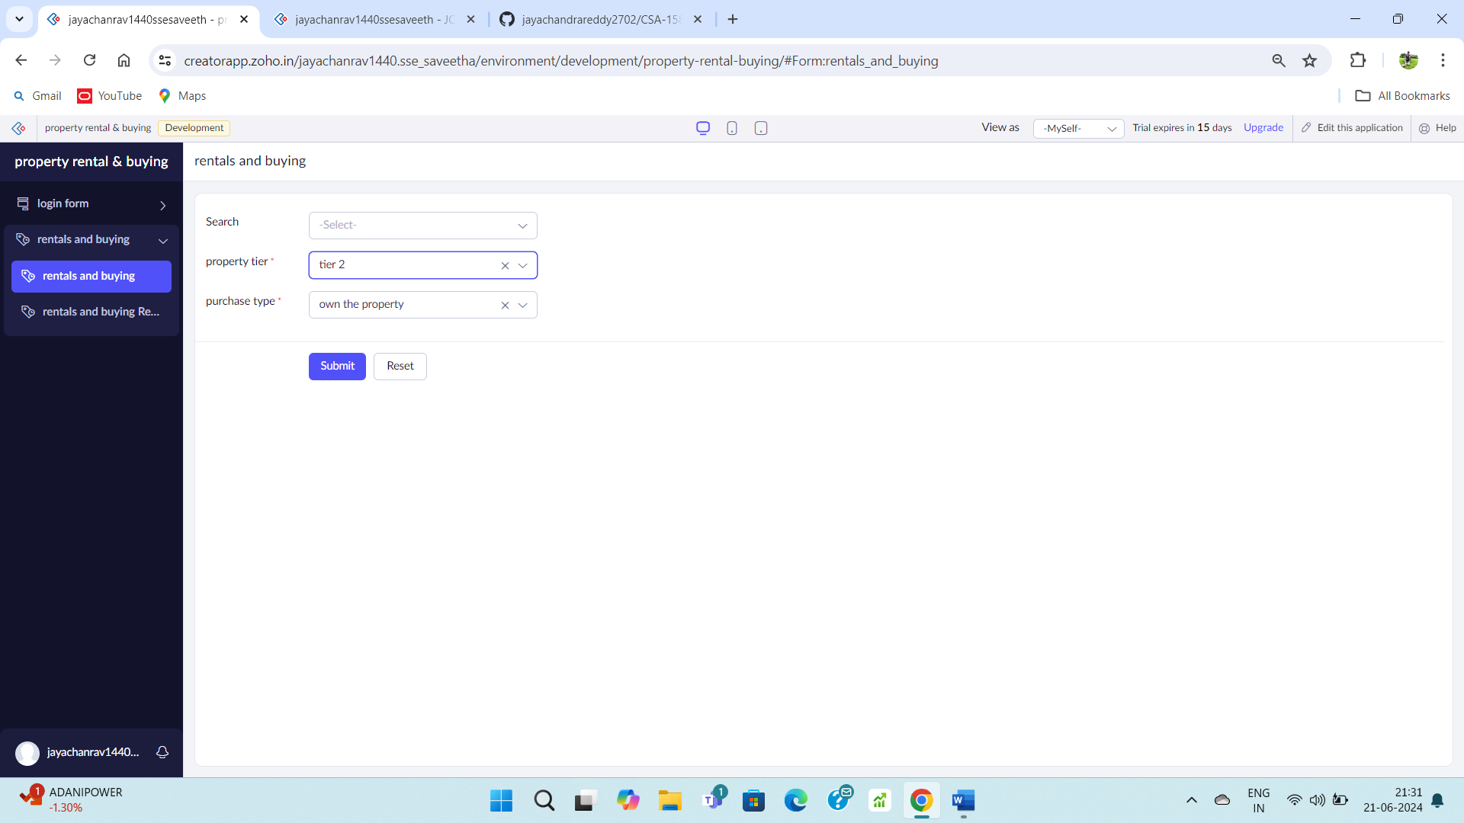

**STEP – 8:**

Go to rentals and buying and rental report form.

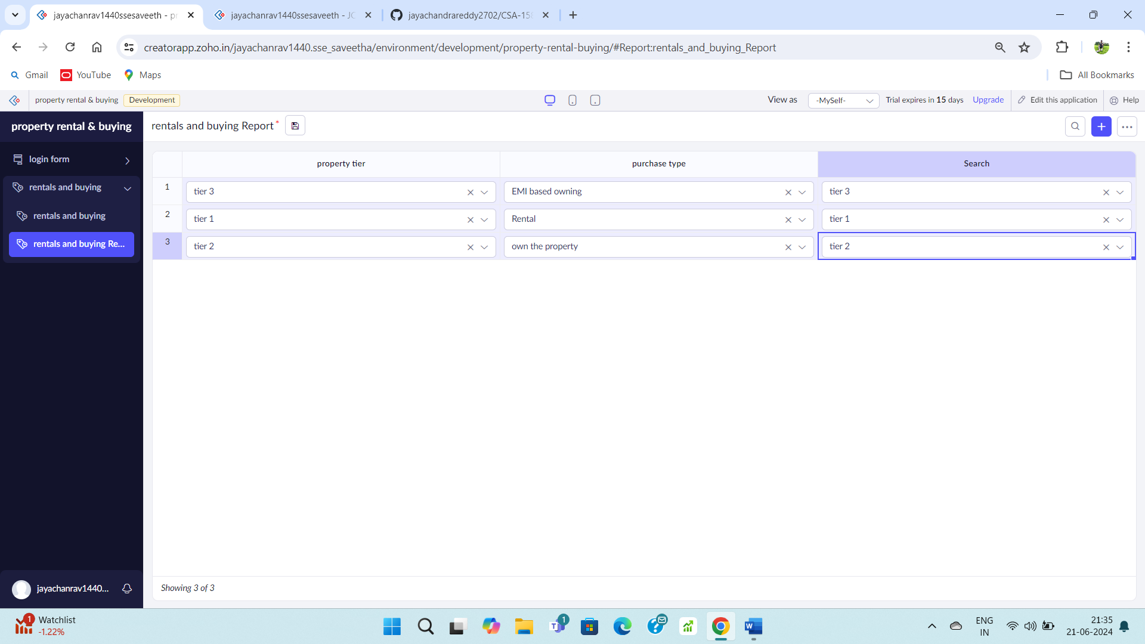

**STEP – 9:**

Create a payment form.

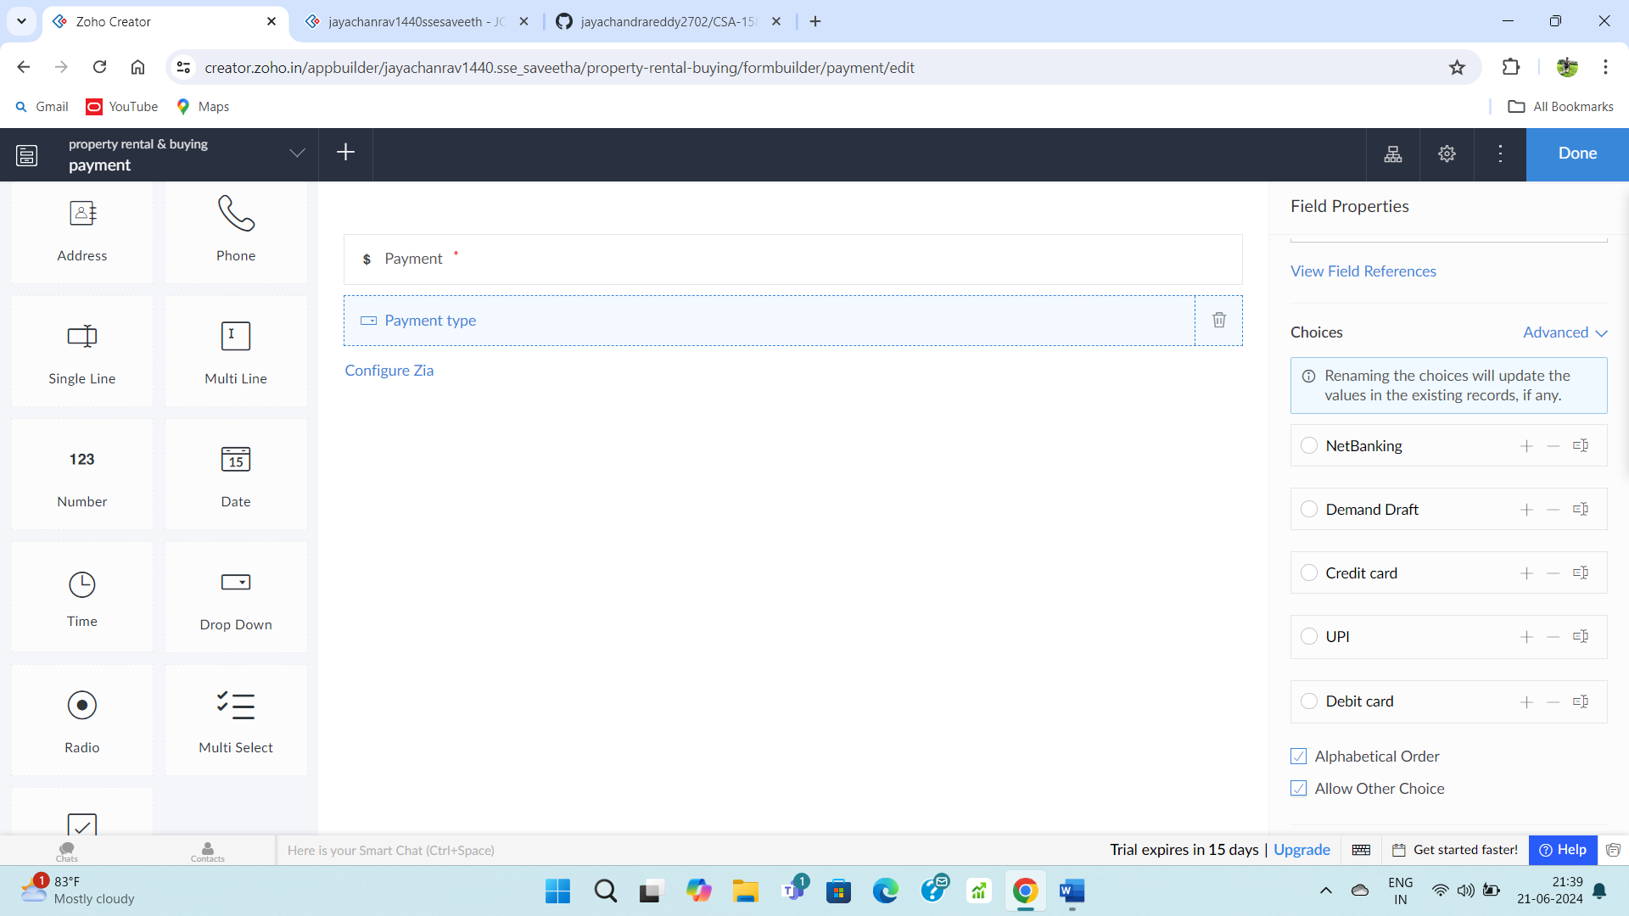

**STEP – 10:**

Fill upon the created form.

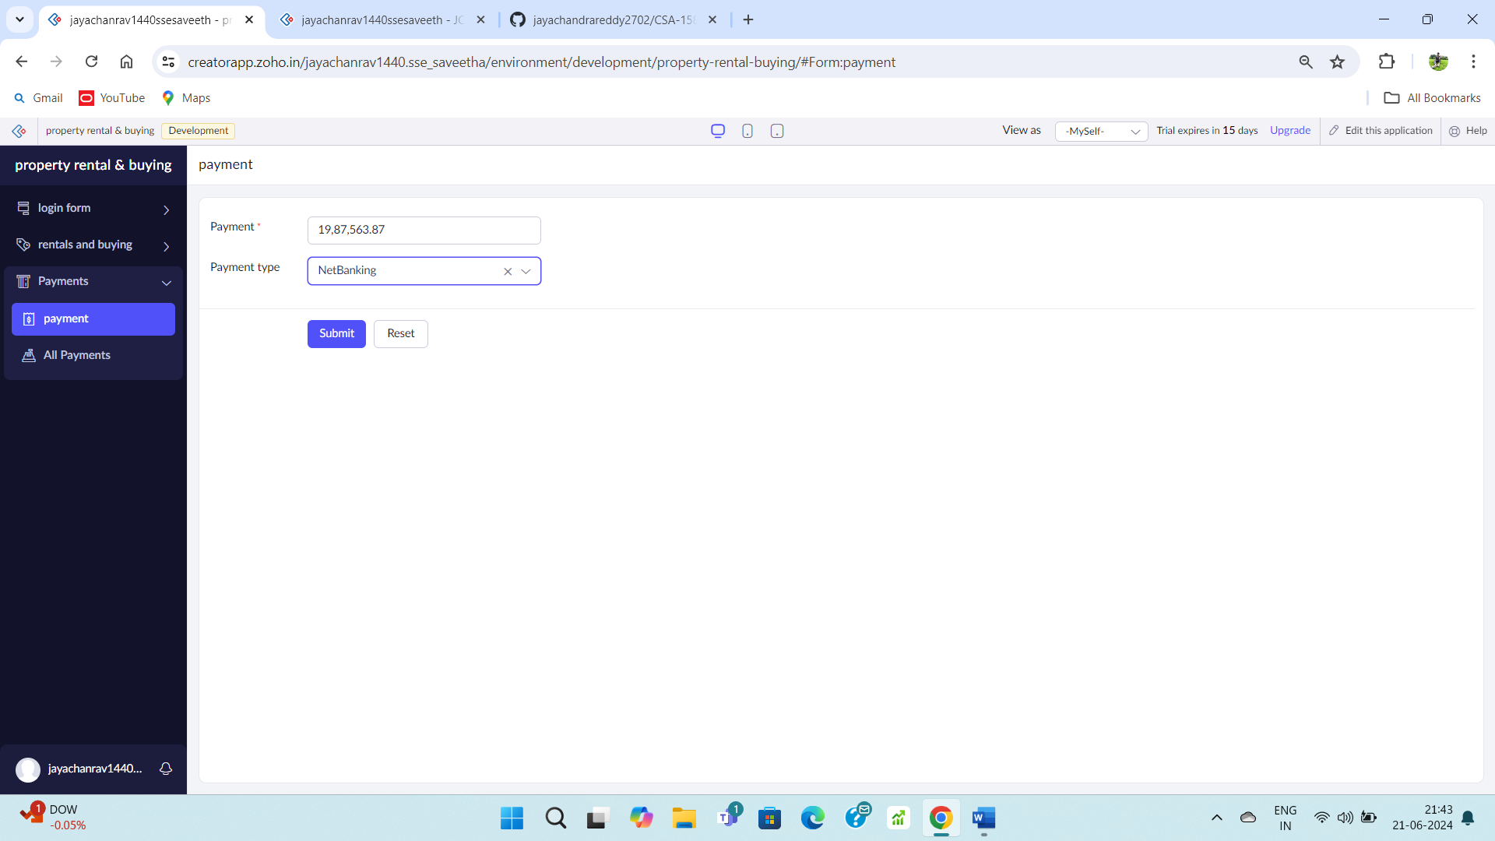

**STEP – 11:**

Go to payment report form.

